Test Case ID | Software Feature | Steps | Expected | Actual Results | Passed  /Failed
TC 1 | View log in by username and password | 1. User to run the programme.  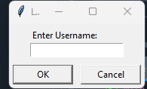  2. input name  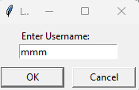  3. click ok when done  4. then the password will show  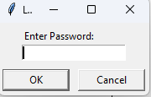  5. input password  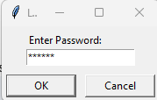  6. if all the data is correct u should have a successful log in  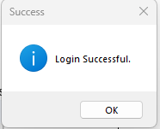  7. success | A list of the details name and password in the code provided such as “mmm” for the username and the password will be “mmm123” as you will put these details in the boxes you will get a successful outcome as it will work without any error | The results were good no error or wrong outcomes as happen, everything went as   | P
TC 2 | Check if validation works | 1. User to run the programme.  2. will input wrong name and password      3. see the incorrect data details  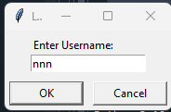  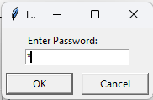  4. results  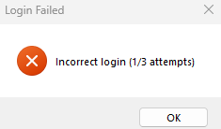 | It will show error for the log in as it was the wrong details been inputted as you can see by the first TC 1 the correct details are “mmm” for the username and the password will be “mmm123” and the details I have put are “nnn” for the username and the password 1 single input as you can see the password as 6 as you can see by the SS provided | An error did show up as intended, without any issues   | P
TC 3 | Verifying the limits of error attempts | 1. User will know put input incorrect name and password  2. checking the numbers go up for attempts    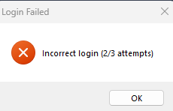  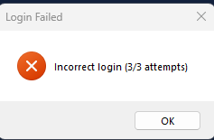  3. number as reached the max  4. results if user continues  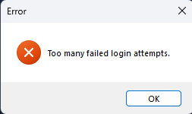  5. success | It should go like 1:3 to 2:3 then to final step 3:3 then if user clicks ok after the max, it should show the user, they failed message = ("Too many failed login attempts.") | It went as I hoped it did    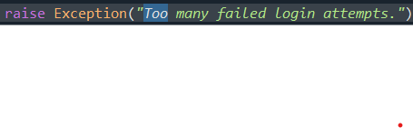 | P
TC 4 | Add doctor and View doctor | - User will know see 3 options  - Users know picks what to click first  - User clicks add doctor  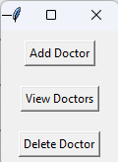  - User add doctor  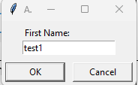  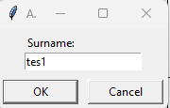  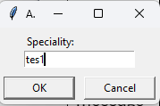  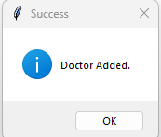  - User know goes back  - User know clicks the view    - User can view doctor  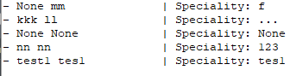    - Success for both | User should a box with 3 options like add doctor and view doctor and nothing else, also be available to not get any | It does get a new doctor to be added and it will display on the view option as you can see on the results    These part work as I like    This final part is good everything works | P
TC 5 | Add patient and View patient | - User know see 3 options; however, this section is only for 2  - User can know choose what to click (add patient and view patients)  - User clicks add patient  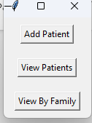  - Users add patient  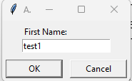  - User adds the details  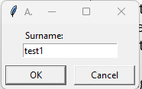  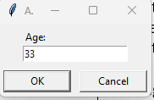  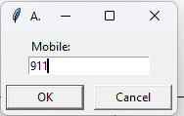  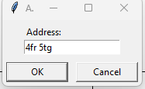  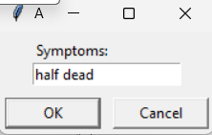  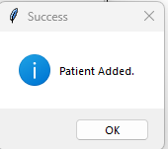  - User goes back  - User can know click the view patient  - User views, patient  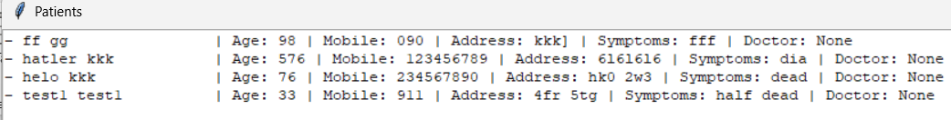     | User should a box with 3 options like add patient and view patient and nothing else, also be available to not get any | User gets a to add a patient and gets to see the added patient      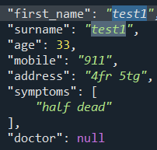 | P
TC 6 | Bonus u can see if the patient is related by name | - User will know see the 3rd option  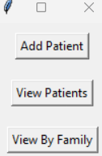  - User clicks the bonus option to see filter option  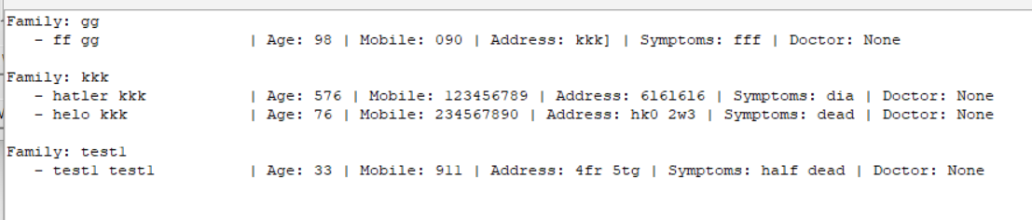     | User will be available to see the patient by design of similar name for example (ww) family will only see (ww) on the list nothing else | The test when as I liked the results, without any issue or errors   | p
TC 7 | Assign doctor | - User know see the list of patients  - User know can choose the number from the SS I provided its between 1-4  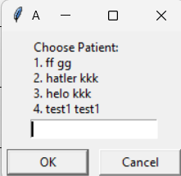  - User picks patient  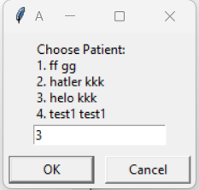  - User picks 3  - User selects doctor  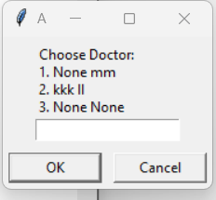  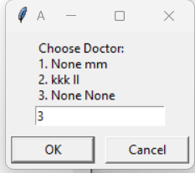  - User picks 3  - Results  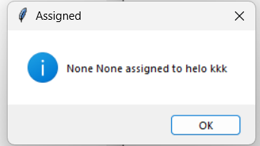  - Display for the results. | User should be available to mix the patient and doctor | The results show that the doctor to + patient has been done correctly has the doctor know show up to the listed patient when I go to my view patient   | p
TC 8 | Discharge patient and view it | - User will see the current list of patients.  - User know can choose the number from the SS I provided its between 1-4  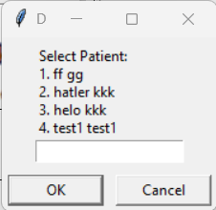  - User picks patient to discharge  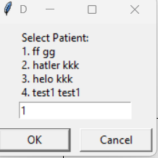  - User choose 1  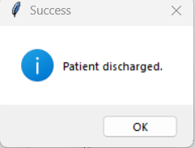  - Success  - User can also view it  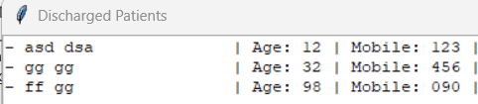  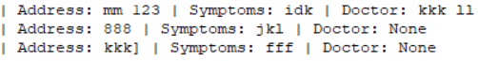 | It should go like user picks the patient to basically remove and it will be removed and later you will see it on the | You should get a respond telling you that the patient has been discharge    It should also get the update for the display   | p
TC 9 | Update admin info | - User can know click the 2nd to last option.  - User clicks update admin info  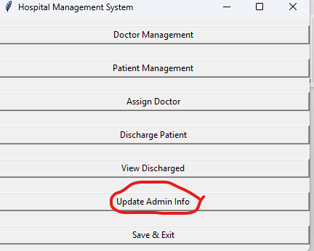  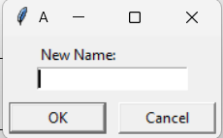  - Input new name  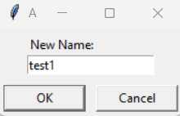  - Input new address  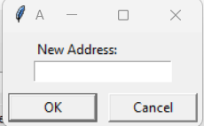  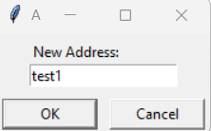  - Results  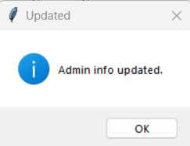 | It should be 2 processes  New name +  New address  Nothing else to be seen or done | This is the results that I wanted to see   | p
TC 10 | Save and exit | - User know can choose the last option  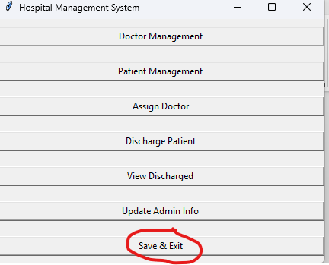  - U click the save and exit  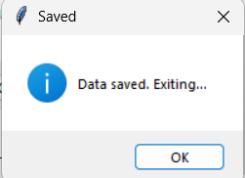  - Success | Everything you did will be saved and exit, any new things like a new doctor, new patient been added will be stored | My results were good.  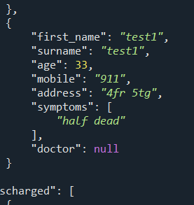  As you can see the data that I put on the previous SS as been saved in the data, as I wanted to show the rest of the saved  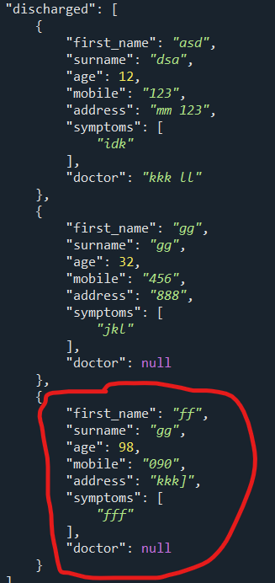  The one in red circle btw | p
https://www.youtube.com/watch?v=RbXBH7JEsHg
https://www.youtube.com/watch?v=epDKamC-V-8
https://www.youtube.com/watch?v=X5yyKZpZ4vU

You will get 1 point per successful test case. However, both quality of the test instructions (steps and expected columns) and the actual result will affect your final mark. For example:
- Assume your program passed all the tests and you provided the screen shots of the result screen, you still won't get 10 if your test cases have poor designed steps and/or are without sufficient instructions, e.g.:
  - bad instruction: enter your admin name.
  - good instruction: enter "Arthur" in the text prompt "Please enter your username:".
- If you have not implemented the relevant feature, you will be able to get a partial mark for a test case as long as your testcase contains well designed steps and meaningful instructions, e.g.:
  - You can have a testcase for GUI with UI mock-ups in the expected column.
- Incomplete test will not be marked, e.g.:
  - A test with insufficient instructions and contains not results.

